Clients & Servers
The client and server work together to deliver the resources required for a website, such as HTML, CSS, JavaScript, images, and other files. The client sends a request to the server using the server's address (URL), and the server processes the request and sends back an appropriate HTTP response containing the requested resource or data.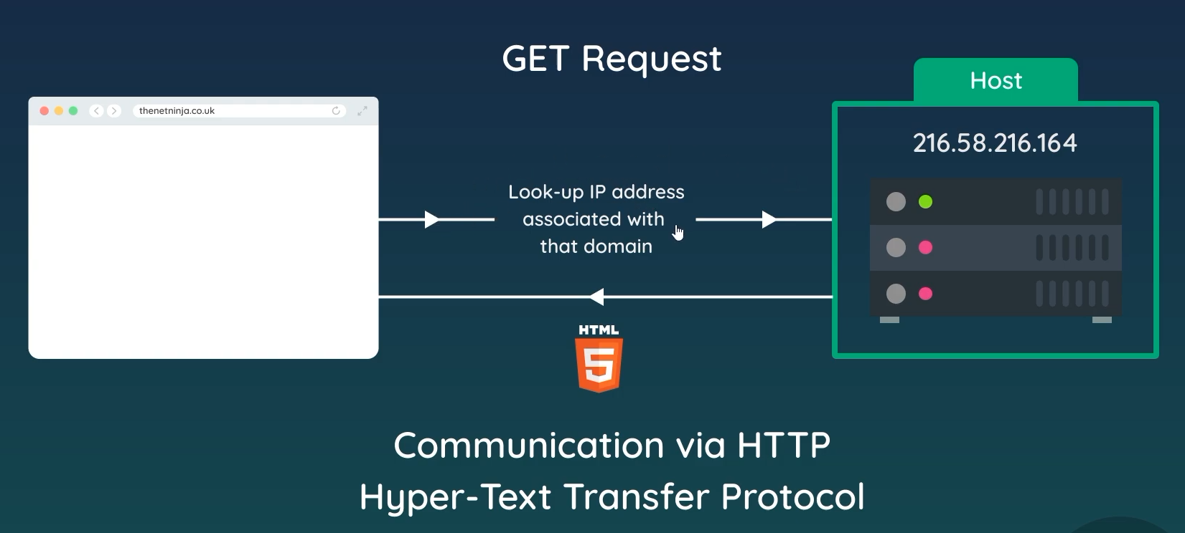
In Node.js, we can create an HTTP server explicitly using Node's built-in http module. This server listens for incoming requests from the browser, processes the request, and determines the appropriate response to send back. Unlike PHP, where the web server typically handles much of the request-processing setup, Node.js allows us to directly create and control the server in our JavaScript code.
Code:- Here, we need the Node.js http module. We use http.createServer() to create an HTTP server, which takes a callback function with two parameters: request (req) and response (res). The request contains information about the incoming request, while the response is used to send a response back to the client.
We then use the listen() method to make the server listen for incoming requests. Here, 3000 is the port number on which the server listens.
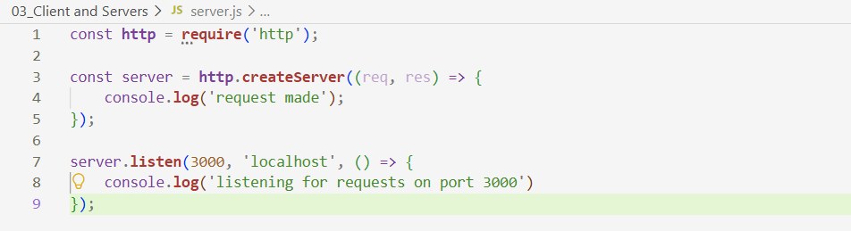
req stores information about the incoming request, including the HTTP method such as GET, POST, PUT, or DELETE. The listen() method can also take a hostname in addition to the port. If no hostname is specified, the server typically listens on the unspecified/local interface according to Node.js behavior; commonly, localhost is used when explicitly binding for local development. The hostname can be changed to allow the server to listen on a different network interface.
The server keeps running and listening on port 3000 for incoming requests. When a request arrives, the server processes it and sends a response, but the server does not automatically close after handling that request. It continues listening for subsequent requests until we explicitly stop or close the server.
If we open localhost:3000 in the browser, the browser will send a GET request to our Node.js server. However, since we haven't written any logic to handle the request or send a response yet, the browser won't display any meaningful content.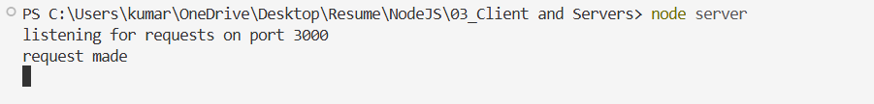
The syntax for createServer() is:-
http.createServer((req, res) => {
// handle request and send response
});
The syntax for listen() is:- server.listen(port, hostname, callback);
Localhost is a loopback address, meaning it refers back to the same computer on which the request is being made. When we use localhost, our computer can act as both the server and the client: the Node.js application runs as the server, while the browser on the same computer acts as the client.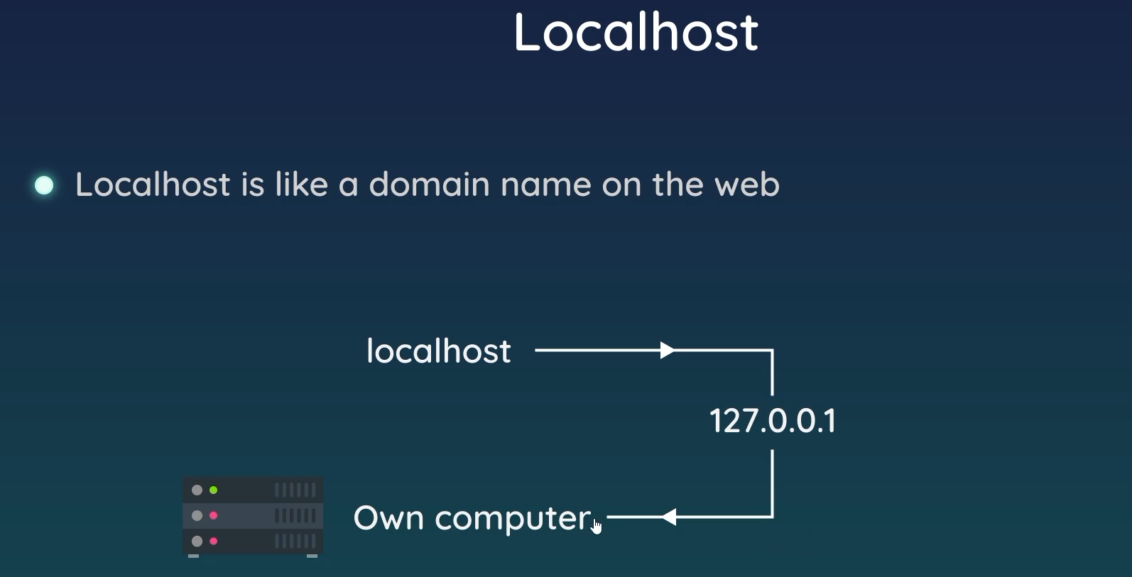

Port numbers can be thought of as doors or endpoints used to direct network traffic to the correct application or service on a computer. Different applications can listen on different port numbers, allowing the operating system to distinguish between their network connections. However, port numbers themselves do not provide security; security is controlled through mechanisms such as firewalls, authentication, encryption, and access rules.

